**Artificial Intelligence**

**What is Artificial Intelligence?**

Artificial Intelligence **i**sa branch computer science that enables a computer to think or act in a ‘human’ way, such as the ability to reason, discover meaning or learn from past experience. In general, AI systems work by processing massive amounts of labelled training data, analysing it for correlations and patterns then follow up on the insights derived from these data. [AI applications](https://en.wikipedia.org/wiki/AI_applications) works with a variety of subfields including [web search](https://en.wikipedia.org/wiki/Web_search) engines, [recommendation systems](https://en.wikipedia.org/wiki/Recommender_system), Automatic Speech Recognition and high-level [strategic games](https://en.wikipedia.org/wiki/Strategic_game).



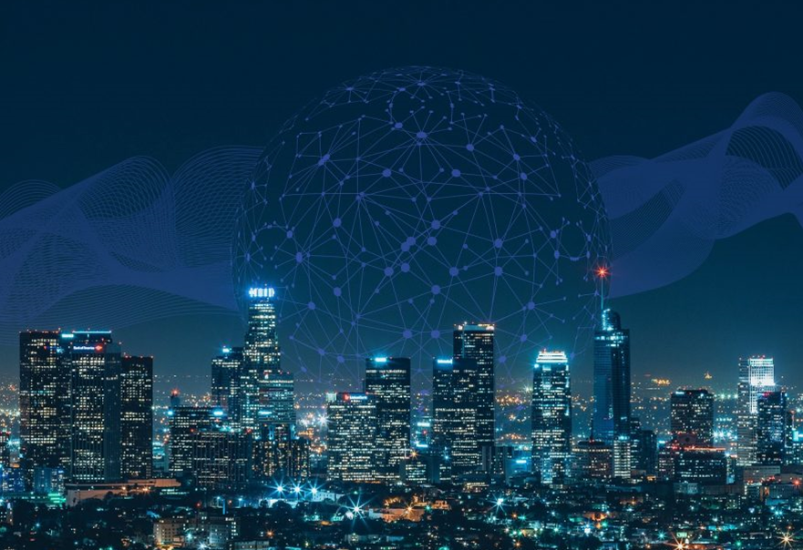

Artificial Intelligence mimics human characteristics, machines are learning what human beings do. This field of science studies the human brain; it’s learning how humans work, decide, and solve problems. All artificial intelligence characteristics whether hypothetical or real comes under the three AI-based abilities:

Artificial Narrow Intelligence  
Artificial General Intelligence  
Artificial Super Intelligence  
  
1- Artificial Narrow Intelligence

Among all types of Artificial Intelligence, this particular one is known by two names, ANI and ‘weak AI’. So, if you ever read about ANI or Weak AI on the internet, do not confuse yourselves as they have the same meaning.

Just to inform you, we are using ‘ANI’ in our discussion to address this type.  
ANI is programmed to execute a single task; it cannot perform more than one unless it is informed to do so. A specific data-set helps ANI to pull out the information being asked — whether it is to write a press-release, analyse raw data, or simply figure out the weekly weather condition.  
ANI has nothing to do with sentiments, neither it is conscious, nor it understands emotions. For example, Google Assistant, and other NLP tools are ANI based.  
You must be wondering why are they ANI based? You talk to Siri, right? Alexa interacts with you, isn’t it?

This confusion is normal, but they are weak because both Alexa and Siri are nowhere close to having intelligence like you. They do not auto-train, don’t have genuine intelligence like other bots, and can’t even speak words on their own because they are pre-programmed to do so.  
  
2- Artificial General Intelligence

GNI or ‘strong AI’ is amongst the types of Artificial Intelligence that can achieve any task a human being can accomplish.

Artificial General Intelligence

This is the type of Artificial Intelligence we have seen in sci-fi movies or series, for example, Gideon was an interactive artificial consciousness (A.I.) in the famous series called “The Flash.” She was hidden in the Time Vault used by Eobard Thawne inside S.T.A.R. Labs. She could interact with Eobard Thawne, was emotionally responsive, and had self-awareness. AGI is clever, has understanding, and act in a way that is the duplication of humans in any given situation. It is anticipated to be able to reason, solve complex problems, make judgments on behalf of humans, to do the planning, and learn based on the knowledge being given.

3- Artificial Super Intelligence

It is assumed that a time will come when Artificial Intelligence will outdo human intelligence.  
“Imagination is but another name for super intelligence.” – Edgar Rice Burroughs. This is the only amongst all types of Artificial Intelligence that people are frightened about. Hawking and Elon Musk are the most prominent among those few, who have already warned us multiples times about the hazards of ASI. Stephen Hawking said, “the emergence of AI could be the worst event in the history of our civilization.”

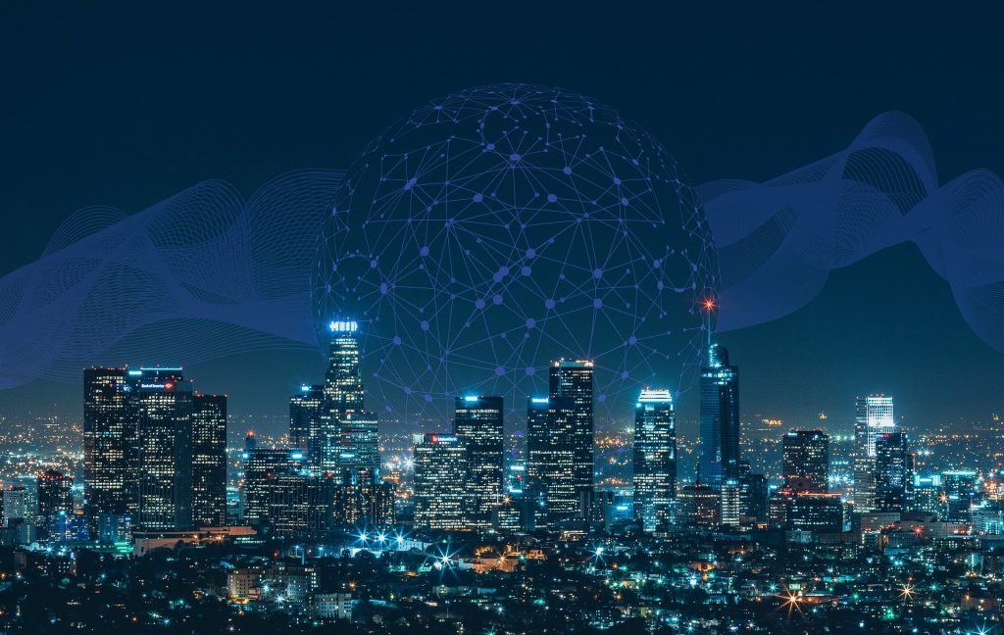

**Artificial Intelligence Benefits**

AI has many benefits for various fields and domains. In Business, AI can help companies reduce errors, reach accuracy with a greater degree of precision, improve efficiency, productivity and innovation. In Healthcare, AI can help doctors diagnose diseases, recommend treatments, monitor patients, and discover new drugs by using data analysis, image recognition.